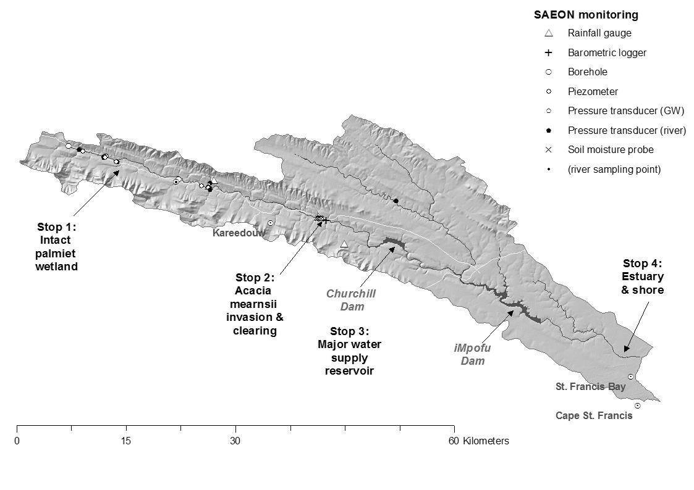
SAEON GSN Indibano – Kromme catchment field trip – Mountains to Sea
Some catchment stats
- Areas: 363 km² to Churchill/Kromrivier Dam, 845 km² to iMpofu Dam - , 1,022 km² to estuary
- Climate, mean annual (to iMpofu)
Things to look for & think about…
- How have people made use of the landscape?
- What impacts do you think this is having? (water, vegetation, ecology, etc)
- What is a “sustainable landscape”?
  - Rainfall: ≈ 620 mm
  - Potential evapotranspiration: ≈ 1300 mm
  - Runoff ratio: ≈15%
- Water supply
  - Churchill: vol 33 Mm³ , supply 20 Mm³/yr (26% of NMM total)
  - iMpofu: vol 107 Mm³ , supply 18 Mm³/yr (23% of NMM total)
- Land cover (to iMpofu)
  - 70% mountainous, 30% floodplain
  - ≈ 86% of former Prionium serratum (palmiet) wetland lost
  - ≈ 70km² Acacia mearnsii (black wattle) cover (28% of floodplain)
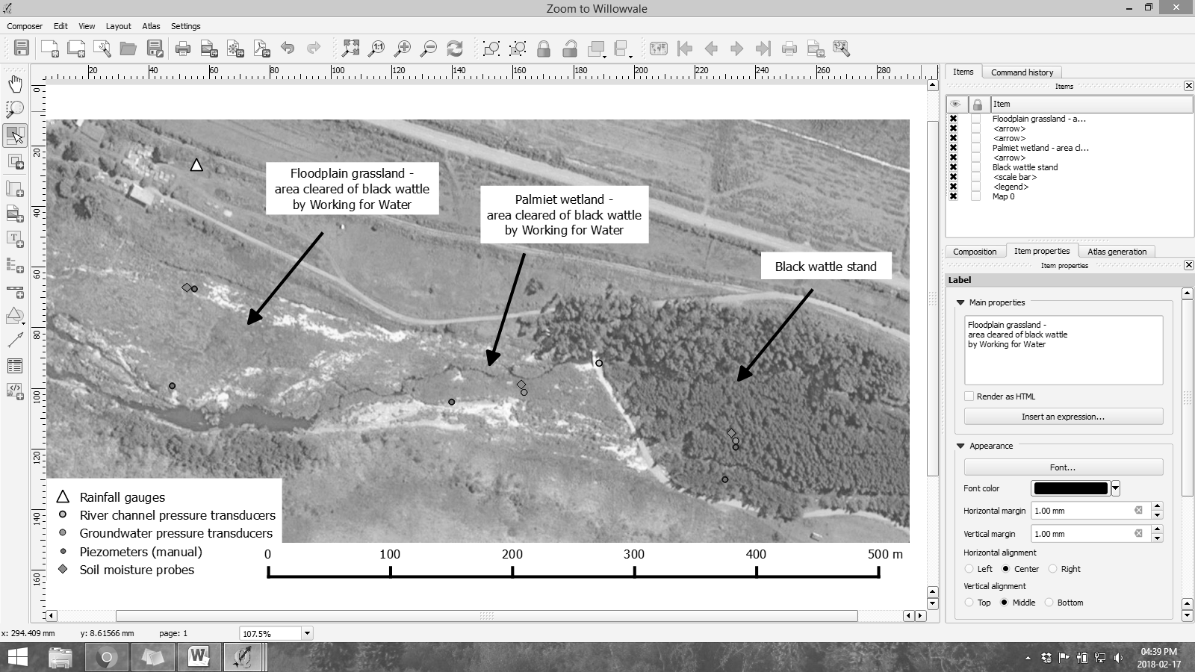
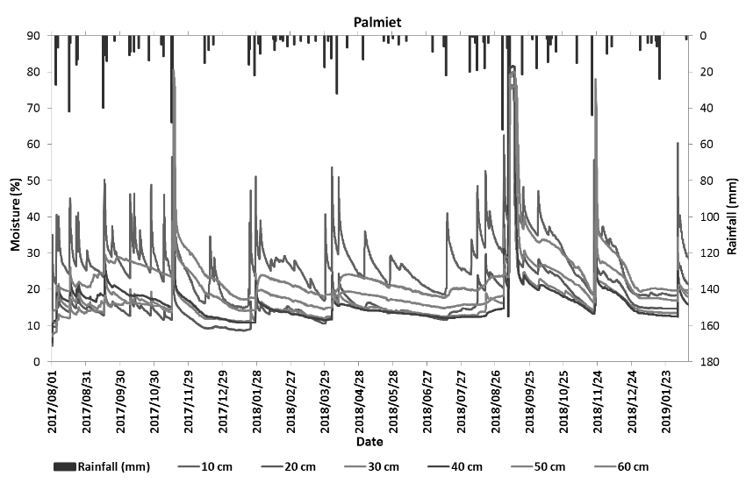
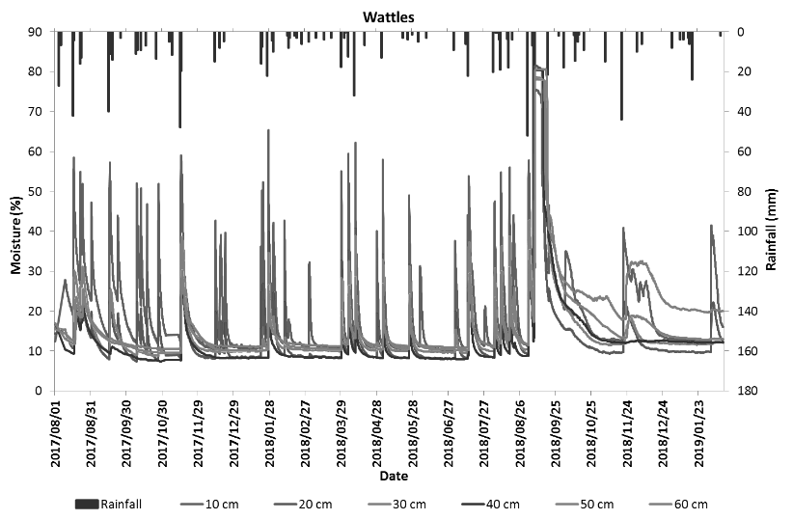
Stop 2: Willowvale Farm

